**Echo command:-**

Echo is a command in Linux that writes its arguments to Standard Output.

In the below image, value 10 is assigned to Variable y. Then using echo, we can print the value as mentioned in below screenshot.

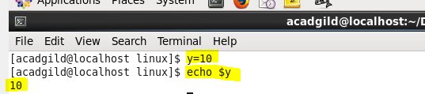

As mentioned in the below image, we can print any string using echo command.



**-e option:-**

Using –e option, echo command will interpret special characters such as new line tab, horizontal tab etc.,

In the below screenshot, with the help of –e option, echo command interprets “\n”(new line) character and interprets the output.

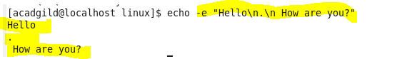

In the below screenshot, with the help of –e option, echo command interprets “\t” (Horizontal tab) character and interprets the output.

